**Campaign Goals – Average Time Spent Per Page All LOB**

**Description:** The graph illustrates the average time spent by users on each page across all Lines of Business (LOB) and sites (PLQB, CLQB, PL CSS, CL Portal). The data displayed (default loading for the average time spent page) corresponds to user engagement over the last 24 hours, and shows the amount of time users spend on each of the pages, in descending order.

For instance,

* Building Details (40.66 seconds) and Locations (38.96 seconds) are the top pages in terms of user engagement time. This suggests that these pages are either content-heavy require detailed user input, or may benefit from simplification to improve efficiency.
* Other moderately high engagement pages include:
* Blankets (15.47 seconds)
* Building Additional Coverages (11.63 seconds)
* Payment (10 seconds)
* Pages such as LocationAdditionalCoverages (2.34 seconds), BuildingClassificationDetail (2.53 seconds), and Mortgage (2.72 seconds) demonstrate lower engagement times, which may indicate streamlined experiences or lesser importance in the user journey.

**Graph Screenshot:**

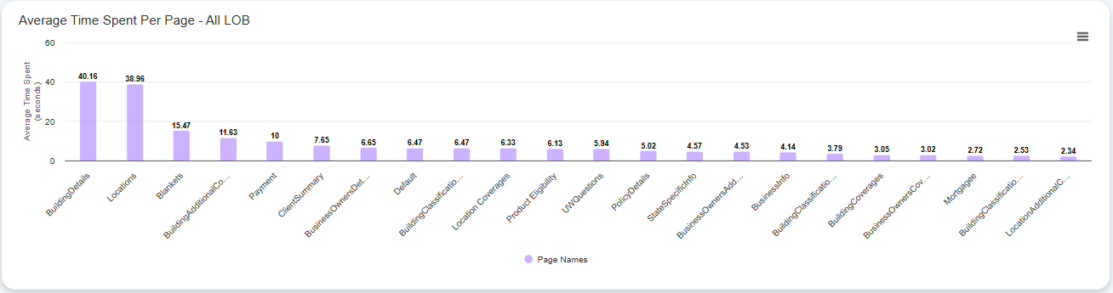

The x-axis shows the page names and the y-axis shows the average time spent (in seconds) on each page in the user journey.